Spearman rank correlation: AUDUSD and EURGBP
Method 02 / daily log returns / Alpari D1 full available history

Study setup
Logical pair: AUDUSD , EURGBP
Broker symbols: AUDUSD_i , EURGBP_i
Snapshot: 2026-11-03_majors_alpari_D1
Timeframe: D1
Matched return window: 1999-01-06 to 2026-11-02 (UTC bar dates)
Matched return count n: 7198
Dropped unfinished last bar dated 2026-11-03 UTC after a tick-volume check against the prior complete day.
Complete matched rows (CSV): AUDUSD-EURGBP_Spearman_D1.csv
Complete matched rows (HTML table): AUDUSD-EURGBP_Spearman_D1_data.html

Method carried forward
Spearman rho is Pearson correlation on the ranks of matched daily log returns of close, ln(close_t / close_t-1), in the broker quote direction. Ties use average ranks. Quotes are not inverted. rho is symmetric under swap of the two symbols. rho = 0 means no consistent rank-order link in this sample; it does not mean no link of any kind. The score is not a cause, not a lead, and not a trading signal. Daily rows are not independent draws, so the two-sided p-value and approximate Fisher interval are reported and treated as secondary to rho. Same-sample Pearson r is shown only as a side check; a large rho minus r gap can flag outliers or a non-straight link.

Results
Spearman rho: 0.064436
Two-sided p-value: 4.46132e-08
Approximate 95% Fisher interval: [0.041395, 0.087408]
Same-sample Pearson r: 0.038173
rho minus r: 0.026263

Conclusion
Over 7198 matched daily log-return rows for AUDUSD and EURGBP (broker quote directions unchanged), Spearman rho is 0.0644 (positive, weak rank-order association in this sample). Approximate 95% Fisher interval: [0.0414, 0.0874]. Same-sample Pearson r is 0.0382 (rho minus r = 0.0263). Two-sided p under the usual independent-ranks model is 4.461e-08; that model does not match linked daily FX returns, so treat p as secondary. This does not establish cause, lead-lag, or a lasting trading rule.

Charts
Daily closes

Daily log returns
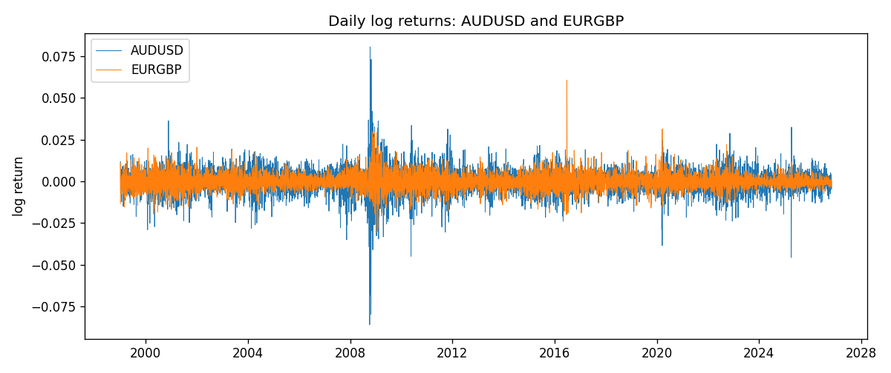
Log-return scatter
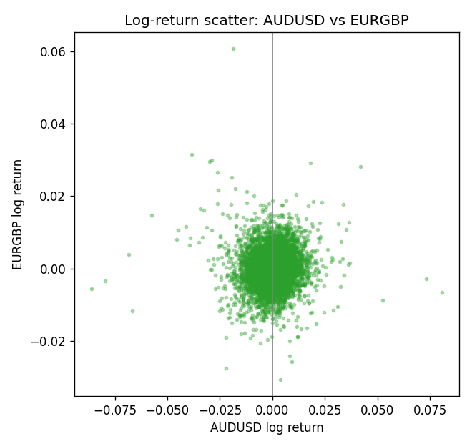
Rank-rank scatter
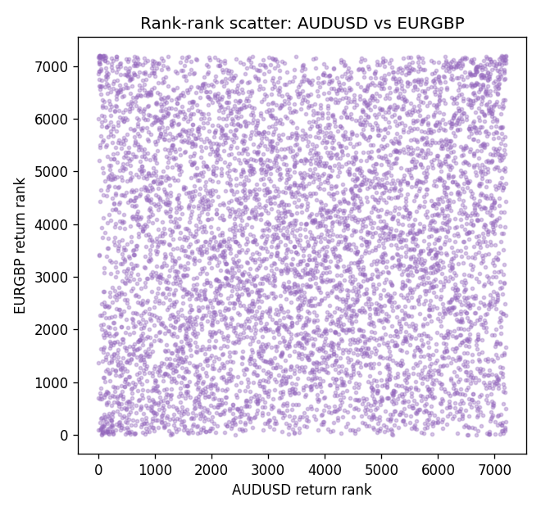

Data report
Every matched row that entered Spearman rho is stored in the sibling CSV named AUDUSD-EURGBP_Spearman_D1.csv. That file is the complete data archive for redrawing charts. Embedding all rows as a Word table is impractical at this length; the Word file holds the column list, column summaries, and the first and last 15 matched rows.
Columns: time, AUDUSD_open, EURGBP_open, AUDUSD_high, EURGBP_high, AUDUSD_low, EURGBP_low, AUDUSD_close, EURGBP_close, AUDUSD_tick_volume, EURGBP_tick_volume, AUDUSD_spread, EURGBP_spread, AUDUSD_real_volume, EURGBP_real_volume, AUDUSD_log_return, EURGBP_log_return
Column summaries (matched calculation rows)
column | count | mean | std | min | 25% | 50% | 75% | max
AUDUSD_open | 7198 | 0.75202191 | 0.13526259 | 0.4785 | 0.6611175 | 0.731685 | 0.8091425 | 1.10284
EURGBP_open | 7198 | 0.78667202 | 0.09675257 | 0.5734 | 0.687325 | 0.83369 | 0.8651775 | 0.9769
AUDUSD_high | 7198 | 0.7560731 | 0.13582215 | 0.4878 | 0.6648025 | 0.7351 | 0.8153975 | 1.10795
EURGBP_high | 7198 | 0.7897492 | 0.09712763 | 0.5789 | 0.6894 | 0.836595 | 0.86804 | 0.9799
AUDUSD_low | 7198 | 0.74796393 | 0.1345766 | 0.4775 | 0.6578225 | 0.727775 | 0.804275 | 1.0975
EURGBP_low | 7198 | 0.7839722 | 0.09657024 | 0.5682 | 0.6853 | 0.831475 | 0.8627775 | 0.9661
AUDUSD_close | 7198 | 0.75206897 | 0.13524509 | 0.4786 | 0.661255 | 0.7318 | 0.8092725 | 1.10169
EURGBP_close | 7198 | 0.78671595 | 0.09675201 | 0.5735 | 0.687525 | 0.83375 | 0.865285 | 0.977
AUDUSD_tick_volume | 7198 | 77378.184 | 138156.24 | 109 | 5445.75 | 43349.5 | 71356.75 | 1234623
EURGBP_tick_volume | 7198 | 86961.088 | 145396.59 | 332 | 6520.25 | 44270 | 81329 | 1424684
AUDUSD_spread | 7198 | 30.809114 | 16.88495 | 0 | 13 | 30 | 50 | 50
EURGBP_spread | 7198 | 21.389692 | 19.14164 | 0 | 4 | 13 | 50 | 50
AUDUSD_real_volume | 7198 | 5.2442754e+09 | 1.2540657e+11 | 0 | 0 | 0 | 0 | 3.811512e+12
EURGBP_real_volume | 7198 | 2.7809077e+10 | 1.3507993e+11 | 0 | 0 | 0 | 0 | 3.5726265e+12
AUDUSD_log_return | 7198 | 2.054e-05 | 0.00754782 | -0.08602525 | -0.00386556 | 0.00027727 | 0.00415374 | 0.0806166
EURGBP_log_return | 7198 | 2.199e-05 | 0.00487197 | -0.03067367 | -0.00262256 | -0.00010006 | 0.00256155 | 0.06075387
First 15 matched rows (selected columns)
time | AUDUSD_close | EURGBP_close | AUDUSD_log_return | EURGBP_log_return | AUDUSD_tick_volume | EURGBP_tick_volume
1999-01-06 | 0.6289 | 0.7019 | 0.011836351 | -0.013303338 | 1412 | 2635
1999-01-07 | 0.6345 | 0.7097 | 0.0088650256 | 0.011051402 | 1468 | 2464
1999-01-08 | 0.6347 | 0.7062 | 0.00031515916 | -0.004943862 | 1225 | 3132
1999-01-11 | 0.6393 | 0.7053 | 0.0072213815 | -0.0012752393 | 1318 | 2418
1999-01-12 | 0.6362 | 0.7077 | -0.0048608485 | 0.0033970309 | 1908 | 2670
1999-01-13 | 0.6312 | 0.708 | -0.0078902098 | 0.00042381861 | 1829 | 2612
1999-01-14 | 0.6295 | 0.7066 | -0.002696916 | -0.0019793588 | 1593 | 2560
1999-01-15 | 0.634 | 0.7012 | 0.007123101 | -0.0076715819 | 1604 | 3031
1999-01-18 | 0.6346 | 0.7017 | 0.00094592471 | 0.00071280921 | 1430 | 2461
1999-01-19 | 0.6392 | 0.7007 | 0.0072225153 | -0.0014261269 | 1733 | 2606
1999-01-20 | 0.64 | 0.7021 | 0.0012507819 | 0.0019960086 | 1901 | 2341
1999-01-21 | 0.6405 | 0.7016 | 0.00078094498 | -0.00071240297 | 1946 | 2450
1999-01-22 | 0.6327 | 0.7004 | -0.012252745 | -0.0017118406 | 1875 | 2600
1999-01-25 | 0.6302 | 0.6966 | -0.0039591468 | -0.0054402425 | 1413 | 2304
1999-01-26 | 0.6305 | 0.6962 | 0.00047592608 | -0.00057438255 | 1755 | 3025
Last 15 matched rows (selected columns)
time | AUDUSD_close | EURGBP_close | AUDUSD_log_return | EURGBP_log_return | AUDUSD_tick_volume | EURGBP_tick_volume
2026-10-13 | 0.69821 | 0.84458 | 0.0035007712 | 0.00020130374 | 34335 | 30915
2026-10-14 | 0.69715 | 0.84553 | -0.0015193215 | 0.0011241873 | 43650 | 39105
2026-10-15 | 0.69191 | 0.84479 | -0.0075447063 | -0.00087557391 | 50656 | 45290
2026-10-16 | 0.69426 | 0.84307 | 0.0033906408 | -0.0020380844 | 40991 | 39309
2026-10-19 | 0.6978 | 0.84259 | 0.0050859986 | -0.00056950988 | 37273 | 38133
2026-10-20 | 0.70022 | 0.83957 | 0.0034620426 | -0.0035906254 | 38736 | 42542
2026-10-21 | 0.70275 | 0.83839 | 0.0036066384 | -0.00140647 | 36307 | 35843
2026-10-22 | 0.70186 | 0.83682 | -0.0012672558 | -0.0018743924 | 43496 | 44479
2026-10-23 | 0.70353 | 0.83751 | 0.0023765656 | 0.00082421033 | 39675 | 37399
2026-10-26 | 0.70128 | 0.83762 | -0.0032032829 | 0.00013133309 | 35142 | 38735
2026-10-27 | 0.70245 | 0.83595 | 0.0016669876 | -0.0019957343 | 34625 | 36303
2026-10-28 | 0.70533 | 0.83651 | 0.0040915541 | 0.00066967224 | 46279 | 36532
2026-10-29 | 0.70245 | 0.83553 | -0.0040915541 | -0.0011722209 | 45705 | 49261
2026-10-30 | 0.70316 | 0.83351 | 0.0010102376 | -0.0024205543 | 42925 | 44060
2026-11-02 | 0.69971 | 0.83426 | -0.0049184984 | 0.00089940465 | 41137 | 43437

